Smart Farmer - IOT Enabled Smart Farming Application

**Sprint – 2:**

|  |  |
| --- | --- |
| **Team ID** | PNT2022TMID550617 |
| **Team Leader** | MARI MUTHU.K |
| **Team Members** | ESAKKI MUTHU.P  SURESH.G  KANNAN.T  THEN RAJAN |

Button:

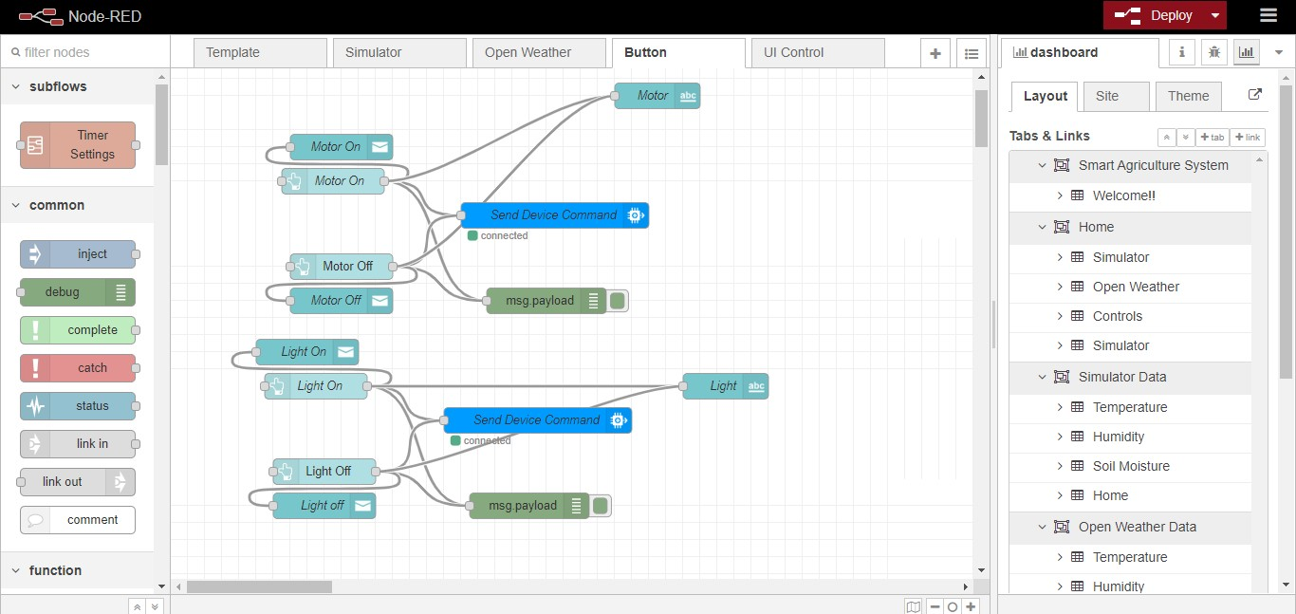

Open Weather:

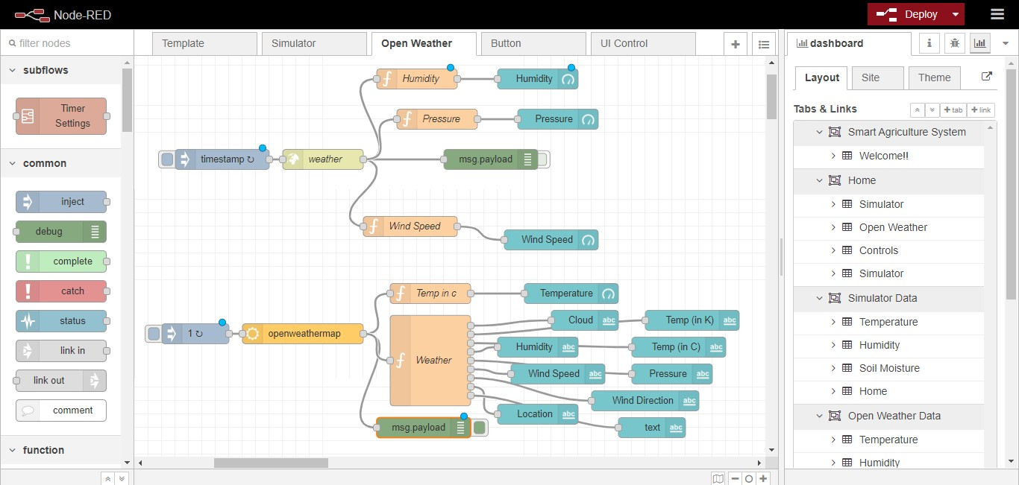

Simulator:

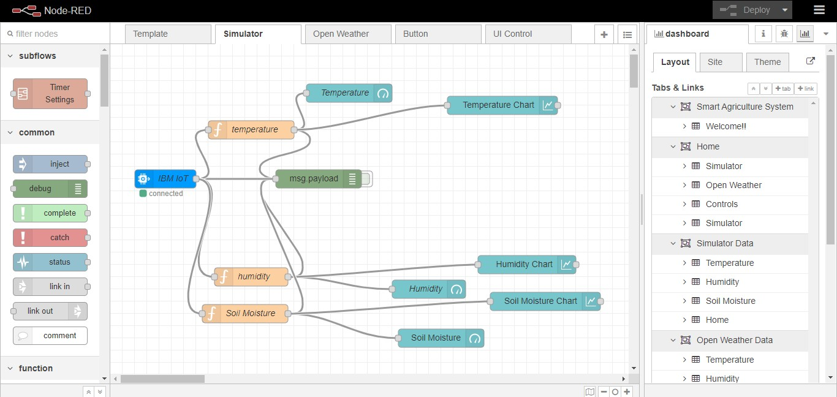

UI Control:

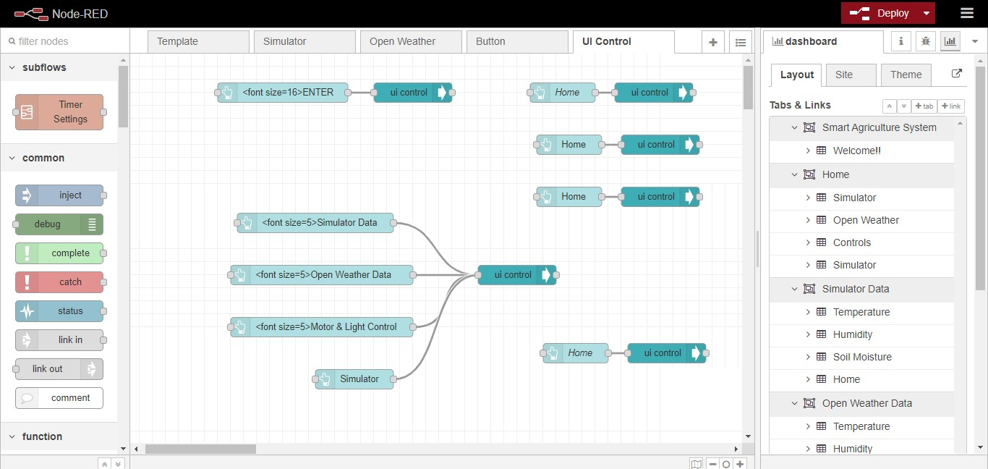

Web UI Output:

